Black Farmland Loss Needs Assessment

Interview and Survey Report

Submitted to the Z. Smith Reynolds Foundation

August 18, 2011

Molly De Marco, PhD MPH
Dania Davy, Esq.
Ruth Baldwin, Esq.

land loss prevention project

Supported by a grant from the Z. Smith Reynolds Foundation
Table of Contents

Title of Section | Page
Acknowledgements | 3
Executive Summary | 4
Background | 6
Methods | 7
Interviews | 8
Survey | 8
Findings
Interview Results | 9
Discrimination | 9
Estate Planning | 11
Health Needs | 11
Educational Needs | 12
Survey Results
Participant characteristics | 13
Experience with discrimination | 14
Estate planning | 15
Health concerns | 15
Needed farm support | 17
Greatest needs of Black Farmers today | 16
Discussion | 18
Recommendations | 19
Limitations | 22
Conclusions | 22
References | 24
Appendix A: Black Land Loss Needs Assessment Interview Guide | 25
Appendix B: Black Farmland Loss Needs Survey | 30
Appendix C: Grant Opportunities for Low Resource and Minority Farmers | 36

Acknowledgements
We would like to acknowledge the contributions of those Black farmers who took the time to patiently answer our interview and survey questions and our partners who helped us connect to these farmers: Shauna Williams, Dorothy Williams, James Dunn, and Keith Baldwin. Thanks also go to student research assistants Cordon Folds and Meredith Robbins for their assistance with recruitment and interviewing.
Executive Summary
Researchers from the Center for Health Promotion and Disease Prevention (HPDP) at the University of North Carolina at Chapel Hill partnered with attorneys from the Land Loss Prevention Project (LLPP) to conduct this needs assessment of Black farmers in North Carolina. The needs assessment summarized in this report aims to provide information to determine: (1) Whether land preservation needs, such as legal consultation, are being met, and if not, what needs exist and (2) The extent of mental health issues being experienced by Black farmers, especially those related to the loss of their land. The needs assessment was conducted in two phases. In the initial phase interviews were conducted with a small group of Black farmers. In the second phase, a short survey was developed and administered to Black farmers throughout North Carolina
The eight farmers we interviewed are all males and live in the Piedmont or Down East regions of North Carolina, regions of the state where most African American farmers reside. Of the eight interviewed, three had come back to farming after retiring from other careers. All reported experiences with discrimination when attempting to obtain a loan for their farm. Further, nearly all reported health effects resulting from their experiences with farming. Last, some farmers had estate plans, but not all. All farmers provided ideas that would help Black farmers to hold onto their land and thrive.
We had 45 Black farmers respond to the survey. The average age of respondents is 59 years. Exactly half of respondents are male and half were female. Over 25% of respondents have a college degree (25.6%) and nearly that many have a graduate or professional degree (23.6%). Almost half of respondents reported a yearly income range of $19,999 or less (45.2%). The average number of years farming reported was 20.7 years. Many of the respondents either worked off the farm (28.9%) or had a household member who did (30.9%). Of those who completed the survey, 44.4% reported experience with being denied a loan. Of those denied a loan, 90% felt it was because of race. More respondents reported having a plan for who would take over the farm than had an actual will (54.6% vs. 36.4%).

All of those interviewed and nearly half of those farmers who completed a survey had been denied a loan and this has occurred in every one of the last six decades up to and including the 2010s. This denial of loans has resulted in less ability to purchase up-to-date equipment and to expand the farm, making the farmers less competitive. In addition, Black farmers report experiencing disputes about land ownership and while the majority have an idea of who they want to take over their farm, far fewer actually had a will in place. Mental health issues were reported to a lesser extent than land preservation needs, but both interviewees and survey respondents had experienced conditions related to stress such as high blood pressure. The findings of this needs assessment suggest a number of recommendations that would improve the well-being of Black farmers in North Carolina. These recommendations fall into estate planning and land preservation, mental health, and funding opportunities and grant-making categories.

It is clear that Black farmers in North Carolina have experienced discrimination surrounding accessing capital for farming as seen by the large numbers of plaintiffs in lawsuits like Pigford v. Glickman and in the stories shared and data collected here. Much of this discrimination was experienced in the past, though, perhaps surprisingly, farmers are still reporting experiences with discrimination in lending. These experiences continue to affect the livelihoods of Black farmers today. These consequences include smaller, less economically viable farm operations and mental health issues brought on through the struggle to hold onto one’s farmland. These farmers, however, expressed repeatedly their love for farming, their perseverance, and ingenuity in maintaining their farmland and their vocation. Those who provide services to and work with Black farmers should come together to address the continued discrimination and develop innovative strategies to encourage estate planning and mental health care access when needed.
Black Farmland Loss Needs Assessment
Report
Background

The 2007 U.S. Census counted 41,024 African-American farmers, equivalent to 1 in 80 farmers (USDA, 2009). The Census of Agriculture has revealed that Black farmers are 3 to 5 times as likely as their White counterparts to lose part or all of their land from one decade to the next (USDA, 2009). The Southern U.S. is hardest hit with the greatest decline in African-American-owned farms seen in the fifteen Southern States. These states experienced a 45% reduction between 1982 and 1997 in African-American-owned farms. Among these, North Carolina experienced the greatest loss at 66% in that time period (Wood & Gilbert, 2000).
North Carolina has one of the largest populations of Black farmers and highest rates of Black farmland loss in the country as noted above. Based on the North Carolina Census of Agriculture, in 1992, Black farmers owned 164,728 acres, but by 2007 they only owned 152,519 acres, a loss of 12,209 acres of land in a 15-year period. For this same time period, Black farmland owners were five times more likely than White farmland owners to lose part or all of their land. This disturbing decline continues despite efforts made by legal service providers, such as the Land Loss Prevention Project (LLPP), to eliminate this disparate loss of land.
One of the dominant reasons that Black farmers are losing their land at disproportionally high rates is the practice of discriminatory lending. These practices have been so widespread, predominately in the Southern United States, that they spawned a class action lawsuit; Pigford v. Glickman. These discriminatory lending practices included receipt of loans later in the season for Black versus White farmers and denial of loans for Black farmers (Hinson & Robinson, 2008) and have resulted in continued financial problems and the dwindling size of Black-owned farms (Balvanz et al., 2011).
In addition to facing racial discrimination in the arena of accessing capital, Blacks have historically been the victims of inadequate legal support to prevent the further loss of land from one generation to the next. When a landowner dies without leaving a will, North Carolina law determines which heirs have rights to the property, which often results in disputes about how the property should be maintained. While North Carolina law prioritizes the physical division of property amongst the landowner’s heirs, in many cases, the courts allow partition sales to be held instead (N.C. Gen Stat § 46-22). A partition sale is the sale of property, which divides the sale proceeds, instead of the actual land, among the heirs. These partition sales usually mean the family will lose the land at a substantial financial loss.
Experiencing this discrimination has also been linked to decreased self-worth and increased stress. We know from our previous research (Balvanz, Barlow, Lewis, Parker, Samuel, De Marco, Crowder, Owens, Williams, Lightfoot, Ammerman, 2011) and work with clients at risk for losing their land that North Carolina’s Black farmers are experiencing health effects due to the stress of fighting to hold on to that land.
One of the challenges to providing adequate services to this population to assist them in holding onto their land and dealing with the attendant mental health issues has been the lack of comprehensive data on the specific needs of Black farmers. Much of what has been written on Black land loss and its correlation to job creation, economic development and health outcomes is dated and, therefore, does not adequately frame these issues. No comprehensive assessment of the needs of this population currently exists. This information gap has been a significant barrier for providing legal and other important services, such as mental health care, in a way that truly enhances the affected communities. The needs assessment summarized in this report aims to fill that gap by providing information to determine:
- Whether land preservation needs, such as legal consultation, are being met, and if not, what needs exist.

- The extent of mental health issues being experienced by Black farmers, especially those related to the loss of their land.

Methods

Researchers from the Center for Health Promotion and Disease Prevention (HPDP) at the University of North Carolina at Chapel Hill partnered with attorneys from the Land Loss Prevention Project (LLPP) to conduct this needs assessment of Black farmers in North Carolina. HPDP was founded twenty years ago as one of the now 33 Centers for Disease Control and Prevention-funded prevention research centers and has played a leadership role in the national efforts to promote health and prevent disease. The Center’s currently funded activities are carried out in a majority of North Carolina’s 100 counties stretching over 400 miles from Cherokee County in the Appalachian Mountains to Dare County on the Outer Banks. HPDP is home to established researchers who have conducted extensive research on health disparities with a particular focus on the American South. LLPP was founded in 1982 by the North Carolina Association of Black Lawyers to curtail epidemic losses of Black owned land in North Carolina. The organization broadened its mission in 1993 to provide legal support and assistance to all financially distressed and limited resource farmers and landowners in North Carolina. LLPP's advocacy for financially distressed and limited resource farmers involves action in three separate arenas: litigation, public policy, and promoting sustainable agriculture and environmental stewardship.

The needs assessment was conducted in two phases. In the initial phase interviews were conducted with a small group of Black farmers. In the second phase a short survey was developed and administered to Black farmers throughout North Carolina. Details of the methodology for these phases are below.
Interviews
We sought to interview up to ten Black farmers about their experiences with land preservation and its effects to further refine our understanding of the issues Black farmers face and to help develop a survey to be administered to a wider range of Black farmers. We recruited Black farmers for interviews in a variety of ways. During the Minority Landowner Conference in Raleigh, North Carolina, Black farmers were invited to provide their contact information to be recruited via mail to participate in an interview about land loss experiences. Nearly 90 farmers gave their contact information. We sent letters to all farmers asking them to contact one of the authors if they were willing to be interviewed, in accordance with our protocol approved by the University of North Carolina at Chapel Hill Institutional Review Board for the protection of human subjects. Via this method, we had five farmers contact us who were willing to be interviewed and we interviewed them. In addition, we called upon our partners throughout the state who work with Black farmers to help us by inviting farmers they knew to be interviewed. We were able to interview an additional three using this avenue. Interviews were conducted either face-to-face (two) or via telephone (six) due to the geographic distribution of the farmers. All participants were fully informed of their rights as study volunteers prior to being interviewed. All interviews were transcribed so that we had written transcripts of each interview. To examine themes and patterns, three study staff reviewed the transcripts. These themes are summarized below. Findings from the interviews were also used to develop the survey. A sample interview guide is attached as Appendix A.
Survey
The survey was developed to reach a broader section of Black farmers in North Carolina than the interviews reached. The survey was created to be short, only six pages long. We kept the survey anonymous to encourage participation. Each participant received two dollars in cash as a token of appreciation. A letter was included with each survey explaining the purpose of the needs assessment and the rights of the participant. Recipients were directed to complete the survey if they were African American, currently or formerly farmed, were over the age of 18, and spoke English. We worked with our statewide contacts to distribute surveys to Black farmers they worked with. We also attended meetings of Black farmers to administer surveys. By working with all of these connections, we were able to get 45 surveys completed. A sample survey is attached as Appendix B.
Findings

Interview Results
Through interviews with Black farmers in North Carolina, we sought to understand experiences with receipt of loans or lack thereof, histories of estate planning, and the health effects of farming under these stressful conditions.
The eight farmers we interviewed were all males and lived in the Piedmont or Down East regions of North Carolina. These are the regions of the state where most African American farmers reside. Of the eight interviewed, three had come back to farming after retiring from other careers. All reported experiences with discrimination when attempting to obtain a loan for their farm. Further, nearly all reported health effects resulting from their experiences with farming.
Last, some farmers had estate plans, but not all. All farmers provided ideas for how to help other Black farmers to hold onto their land and thrive.
Discrimination

Racial discrimination in lending. Nearly all those interviewed reported experiencing discrimination that they attributed to the color of their skin. One farmer believed that racial discrimination in loan practices took place when lenders, "com[e] up with certain excuses." He stated that despite his high credit score, he was told that he was not eligible for loans, which he believes was because of racial discrimination. He explained it this way:

“I heard some people, you know, like say that they got, uh, the...loan and everything and I was asking them…how did they fill out the application and they told me, but now see, I did the same thing.”

Some farmers were told they had been denied loans for reasons such as not having farmed long enough or not having enough land. Others were able to get loans from private banks, but not governmental entities like the United States Department of Agriculture’s (USDA) Farm Service Agency (FSA). Still others, who were able to obtain loans, reported that they received different loan terms from other similarly situated White farmers. Some of these loans required supervision in exactly how the money was spent. Other times, loans were given later in the growing season resulting in later planting and products reaching the market later, making the farmers less competitive.
While many of those interviewed reported discrimination in lending having occurred in the past, one farmer shared his belief that African-American farmers continue to face racial discrimination in access to loans. "If he's black, he's having issues," he stated. This was, in fact, found to be true via the surveys (see below).
Other experiences with discrimination. In addition to discrimination in lending practices, farmers reported other instances of discrimination. One farmer said that he had been denied a home loan when other similarly situated White individuals had received a home loan. Another farmer stated that African-American farmers also experienced discrimination with regard to the price they are able to receive for their produce, in this instance tobacco.
We had some of the prettiest tobacco as anybody, uh, else had but, you know, like he would, uh, they wouldn’t pay him for his tobacco, you know, like the way that it should be.

Ironically, this farmer credits racial discrimination in tobacco prices as the reason he did not smoke tobacco, as he explains:

“That discouraged me from smoking. You know? Because I saw what they was paying us for that tobacco and when we go to the, to the store to buy a pack of cigarettes, the price of cigarettes, you know, and I said, and I made a vow to myself that I would never indulge in smoking because they didn’t pay my daddy, pay us for our tobacco. Why should I go back and pay them for what they want for their tobacco?”

Moreover, another farmer stated that African-Americans face discrimination in the information they receive from agencies. He stated, "A lot of black farmers don’t, uh, don’t receive the information [from the Farmers’ Services and the extension department] in a timely fashion."

Missed opportunities. All those interviewed experienced being denied a loan. Several reported feeling ‘once bitten, twice shy’ about applying again or reported developing a distrust of the government, loan officers, and/or lawyers who had provided advice to them on borrowing given these experiences.
One of the consequences of loan denial and unwillingness to apply again was the loss of opportunities that having received those loans would have provided. Missed opportunities included not being able to expand the size of the farm and the inability to purchase more specialized equipment, which would have allowed the farmer to make extra income.
Growing up with my father farming and what not…I did hang in there trying to farm the land even though my other, uh, brothers and sisters didn’t want to do anything about, he provided this land for us and I would like to hold onto it as long as I can to carry on his legacy.

Economic Hardship. A further consequence of loan denial was that the farm had to be financed in other ways or it would have been lost. One farmer explained that to hold on to his land he used credit cards and depleted his retirement fund.
Despite the hardships experienced, many farmers were committed to farming their land. Some farmers had inherited their land from their fathers and maintaining that legacy was important to them.
Estate Planning
Some of the farmers reported having estate plans in place, while others did not. Several reasons were given for why farmers did not have any estate plans in place. One farmer explained that he hadn’t put an estate plan in place because he was still accumulating land and other assets to leave his children. Another said that he had just not gotten around to drafting a will, not seeing the point, but did feel that he had access to an attorney who would be able to help him when he was ready.
One farmer explained the consequences to his ancestors of not having a plan for land succession, saying that his father had worked two acres under the promise from his two aunts that they were going to leave the farm to him. However, when the aunts passed away, they had not left the proper paperwork for him to inherit the farm. The farmer stated that witnessing this promise to his father go unfulfilled, "kind of put a damper in [his]…spirit of trusting other peoples. You know? Like what they say, unless you got paperwork."
Health Needs
We asked the farmers about any health issues they faced as a result of farming and the denial of loans. The main issues that came up included mental health, physical health conditions, predominately chronic conditions such as high blood pressure, and lack of health insurance intimately tied to the health conditions reported.
Physical Conditions. Those interviewed reported a number of physical ailments that they attributed to farming. A number of the farmers reported having high blood pressure. One farmer reported that farming had played a role in his developing a lung disease. He noted that his doctor had suggested that the disease he developed is common in "black men, you know, like raised around a lot of pine trees."

Mental Health. Nearly all those farmers interviewed reported experiencing stress as a result of the challenges of holding onto their land. One farmer shared that as a consequence of dealing with the racial discrimination related to farming his mental health had been negatively impacted. He stated that he probably needed to "go see a psychiatrist to get [him] back down so [he wouldn't] be so edgy." Dealing with the legal issues related to the above described Pigford settlement and farming had contributed to his two “attempts of heart attacks. “ He also explained that this stress made it hard for him to finish his work.

Another farmer stated that he attributed symptoms like difficulty sleeping, racing heartbeat, heart palpitations, and headaches to the stress and worry of his farming operation. In addition to the role he believed that his farming played on his physical health, a third farmer expressed that the stress of farming had a negative impact on his mental health.

Lack of Health Insurance. A majority of those interviewed reported lacking health insurance. Those who did report being covered by health insurance reported that they had not had coverage until they reached the eligible age for Medicare. This resulted in farmers being unwilling to seek needed care because the out-of-pocket costs were perceived to be too great.
Educational Needs
Farmers were asked about their educational needs in terms of estate planning and land retention and how best to have information delivered.

Despite being denied loans for what he believed were racially discriminatory practices, one African-American farmer still expressed interest in receiving information about government grants that could help him improve his farming practices; however, he made clear that he would not be interested in applying for any additional loans.
I believe that you will find that every farmer would prefer that somebody sit down and talk to them, especially black farmers because they understand the spoken word better and the actions and reactions of the people that’s talking to them, can get through to them better and help them understand.

With regard to attending informational workshops, one farmer reported that he would only be able to attend if these workshops were offered for free or if they offered farmers stipends for attending. He cited the need to stay on the farm to work and the time consuming nature of travel from rural farm communities to larger cities as barriers to attending informational workshops.

One farmer suggested that the best way to impart information to farmers, who have lots of demands on the farm, is to provide one-on-one counseling.

Further, the creative use of technology appears to be a potentially valuable resource for working with African-American farmers. One farmer reported that he would be willing to participate in video conference calls in which he could ask questions and interact with the other participants. This technology is already widely used, but requires a newer model computer and a fairly fast internet connection. Hence, this option could work for farmers who have this technology, but not those who do not.

As part of the survey, farmers offered suggestions as to educational topics that would be of use to them. This information is presented in the next section.

Survey Results
Participant characteristics
We had 45 Black farmers respond to the survey. The average age of respondents was 59 years with a range of 17 to 78 years. Exactly half of respondents were male and half were female. Over 25% of respondents had a college degree (25.6%) and nearly that many had a graduate or professional degree (23.6%). Almost half of respondents reported a yearly income range of $19,999 or less (45.2%) and of those reporting any income from farming (14 out of 39, 6 did not answer), the average percent of income that came from work on the farm was 27.8%. The range was 1 to 100%, but only two respondents reported obtaining 100% of their income from farming. The average number of years farming reported was 20.7 years with a range of 0 to 60 years. Many of the respondents either worked off the farm (28.9%) or had a household member who did (30.9%). See Table 1 for details.
Table 1. Demographics of those who completed the survey (n = 45)
Characteristic | Mean (SD) or Percent (n)
Average Age | 59 years (12.6)
Male | 50% (22)
Educational Attainment
Less than a high school diploma | 4.6% (2)
High school diploma or GED | 13.95% (6)
Vocational, trade, or business school | 9.4% (4)
Some college | 23.3% (10)
College degree | 25.6% (11)
Graduate or professional degree | 23.3% (10)
Yearly Income
$19,999 or less | 45.2%(19)
$20,000-39,999 | 31.0% (13)
$40,000 – 74,999 | 19.0% (8)
$75,000 or more | 4.8% (2)
Percent Income from Farm | 27.8% (34.6)
Years Farming | 20.7 years (18.4)
Currently Working Off Farm | 28.9% (13)
Household Member Working Off Farm | 30.9% (13)
Spouse/partner | 20% (9)
Daughter/son | 4.44% (2)
Father/mother | 4.44 (2)
Note: SD = Standard Deviation, n = number
The types of off-farm jobs farmers reported currently having included bus driver, animal care, day care, construction, fast food, and research technician. The types of jobs other household members were reported to have included driver or trucker (4), doctor, teacher (2), and funeral home assistant.
Experience with discrimination
Of those who completed the survey, 44.4% (20 people, 2 did not answer) reported ever being denied a loan. The average number of loan denials was 2.1 (1.32). The range of times respondents reported being denied a loan was between one and five. Of those denied a loan, 90% felt it was because of race (n = 18) (Table 2).

Table 2. Experience with discrimination in loans
Characteristic | Mean (SD) or Percent (n)
Ever been denied a loan? | 44.4% (20)
Number of times denied a loan? | 2.1 (1.32)
Felt not given loan due to race? | 90% (18)
Note: SD = Standard Deviation, n = number
Farmers reported being denied loans from the USDA (6), private banks (4), the Small Business Administration (2), and the Farm Services Agency (2). A number also reported denials of loans from the Federal Housing Administration (4), although we specifically asked about loans for their farm. Farmers reported the following reasons they were given for not receiving a loan:
EEligibility may have been determined by us walking in the door.

- Poor credit, not enough income, no collateral
- Race
- Family dispute with lending agent
- Not enough pounds per acre being produced
- Farmland is not zoned for intended use
- Too young
Several provided reasons why they felt their race played a role in their loan denials. Reasons included:
- Others who were not Black got loans
- Didn’t want Black farmers to be able to make a profit
- Black farmers’ farming knowledge was discounted
Respondents were asked to report the most recent year they were denied a loan. The most common year given was 2010 (n = 3). The years ranged from 1969 to 2011 with the majority being in the 1980s (n = 5), followed closely by the 2010s (n = 4).

Estate planning
Over half of those completing the survey reported having had a dispute with a family member or neighbor about ownership of his/her farmland (53.3%). Of those who reported such a dispute, 52.2% had been resolved. Of those disputes that had not been resolved, however, only one person had sought legal advice. More respondents reported having a plan for who would take over the farm than had an actual will (54.6% vs. 36.4%). Of those who did report having a will, 17.8% reported being prompted to create one due to the death of a family member or friend, but only 4.4% because of a land dispute (Table 3). Less than 30% of farmers had consulted a lawyer about drafting a will, but 84.6% reported that they did know a lawyer who could help them to draft a will.

Table 3. Estate planning characteristics
Characteristic | Mean (SD) or Percent (n)
Had dispute with family or neighbors over land ownership | 53.3% (24)
Dispute was resolved | 52.2% (12)
If not resolved, was legal advice sought? | 12.5% (1)
Has a succession plan in place | 54.6% (24)
Has a will | 36.4% (16)
Reason prompting creation of a will
Death of a relative or friend | 17.8% (8)
Land dispute | 4.4% (2)
Had consulted a lawyer about drafting a will | 29.3% (12)
Knew a lawyer who could help* | 84.6% (11)
Note: SD = Standard Deviation, n = number
*Of those who had not consulted a lawyer for help drafting a will.
Health concerns
Having to work in all kind of weather. We had to work extra hard to come out with a little money. We were slaves to our farm.
General concerns. Respondents were asked whether they had experienced any health conditions related to farming and only four (9.8%) answered in the affirmative. The following conditions were reported:
- Joint pain
- Back Injury
- Shoulder pain
- ‘Worn down from farming, tired’
Mental Health. Over 30% of respondents (n = 13) reported that they had ever been so stressed that they were unable to work. When asked what kinds of help might be useful to deal with the stress of farming, respondents provided the following suggestions:
- Ability to take a vacation
- Money, receipt of loans (suggested multiple times)
- Stress management techniques
- Counseling
- Help on the farm
- Help finding grant opportunities
- Human relations education: “How to "bargain" across types, against stereotypes. Cross-cultural, -racial, -sexual discussion techniques.”
Health insurance. Surprisingly, over 80% of farmers who provided an answer about having health insurance (seven respondents did not answer) reported that they had some form of health insurance (n = 31). The majority of those with health insurance had Medicare (14) followed by private coverage (10), although the number of those with private insurance is likely higher because when asked to write in ‘other’ coverage that did not fit in the categories provided, two wrote in Blue Cross and one wrote in ‘Mail Handlers’.
Needed farm support
Respondents were asked what support would help them with their farms. As expected, most said that financial assistance would be the biggest support. Many provided more specific suggestions. Table 4 describes these supports.

Table 4. Suggested Support for Farming
Financial
Loans of time & early
Fair access to loans & grants and more cooperation with each other, farming coop, etc.
Money to help to get water off the farm land
Equipment: tractor
Other
ACSC - Water Availability [Agricultural Stabilization and Conservation Service (ASCS), what is now part of the Farm Service Bureau] and access to adequate irrigation systems.
Learn more about marketing skill and how to implement those skills
Markets for farm produce
More up-to-date knowledge
Help transitioning to other enterprises
More help from Extension
County agent that has time to spend with the Black farmers.

Greatest needs of Black Farmers today

We asked respondents to tell us what the greatest needs of Black farmers were today during both the interviews and as part of the self-administered surveys. Table 5 displays these needs. Reported needs included direct financial supports such as grants and loans, assistance in purchasing equipment and supplies, and more complex needs such as access to an improved distribution system.

Table 5. Greatest Needs of Black farmers
Financial
Assistance with purchasing supplies and up-to-date equipment: The cost of crops is still low, but the cost of inputs is increasing.
"Money will get you all that in farming."
Shared community equipment like a combine or tractor
Grant funding from state foundations such as the Golden LEAF Foundation or the Tobacco Trust Fund
Other
Involving the younger generation in farming to interest them in farming as a profession.
"Fairness from the, um, the, the establishment."
Technical assistance with grant writing or a grant writing service
Processing facilities
Assistance understanding legal documents
Dispute resolution
Education:
Farm Safety
Financial planning
Soils
Crop pricing
Marketing
Farm management
Less regulation

We also asked Black farmers to suggest ways that these needs could be addressed. Table 6 provides their answers and we include some information provided during the interviews as well. One suggestion was to implement an equipment-sharing cooperative so that expensive equipment such as a combine could be shared and borrowed on a rotating schedule. This is currently being done in the Piedmont among nine small farmers through a grant from the North Carolina Tobacco Trust Fund, a program that is unable to award grants for fiscal year 2011 due to a diversion of funds related to the budget deficit in the State.
People in authority need to want change.

Table 6. What are some ways these needs can be addressed?
Financial
Funding, donations, loans
Reparations
More professionals to provide assistance in obtaining funds
Other
Shared supplies such as a combine that could be shared among a number of small farmers
- Extension agents to facilitate this.
Education provided at USDA and Extension meetings, meetings in rural communities, directly to Black farmers
Assurance of getting crops to market
Separation of real farmers from cooperative farmers

A number of farmers suggested in both the interviews and the surveys that education would help Black farmers. In the interviews, however, farmers let us know that they would have limited time that they could take away from their farm to attend classes. One idea is to provide web-based educational tools. This would, however, only work for those who had adequate access to the internet. Nearly 90% of those who completed a survey reported having access to the internet (87.8%, n = 36). Of those with internet access, 51.1% reported having access in their home (n = 23), 13.1% at work (n = 6), 6.7% at the home of a family member or friend (n = 3), and 8.9% at the library (n = 4), making web-based educational resources somewhat useful.
Discussion

All of those interviewed and nearly half of those farmers who completed a survey had been denied a loan and this has occurred in every one of the last six decades up to, and including, the 2010s. This denial of loans has resulted in less ability to purchase up-to-date equipment and to expand the farm, making the farmers less competitive. In addition, Black farmers report experiencing disputes about land ownership and while the majority have an idea of who they want to take over their farm, far fewer actually have a will in place. All of this provides evidence of a need for land preservation support in the Black farmer community.

The farmers who responded to the survey portion of this needs assessment, in particular, had high educational attainment. This is most likely because of the way that farmers were recruited. Nearly all of the participants were recruited at meetings for Black farmers (either meetings of private organizations or public institutions) suggesting that they were well enough connected to know about the meetings and we know that those with more education have larger social networks. Given the education level, it is of interest that relatively few had created a will, though many reported knowing a lawyer who could help create one. This suggests that there are other barriers to making a will. We have found through our work with Black farmers that many are uncomfortable talking about death and dying, making the discussion of creating a will unwelcome. Many participants did report having an idea of who should take over their farm, however that would not protect these farmers from a partition sale should they die without a will in place. Hence, it is apparent that land preservation needs exist.

Mental health issues were reported to a lesser extent than land preservation needs, but both interviewers and survey respondents had experienced conditions related to stress such as high blood pressure. Of note, nearly all those interviewed reported experiencing stress-related symptoms such as headaches and a racing heart, while less than a third of survey participants did. This discrepancy may be due, in part, to the fact the interviewers could probe the farmers they interviewed about their experiences, which would have led to more sharing of information than a self-report survey.

Fewer farmers reported problems with stress and mental health than we expected from our previous work with this population. Moreover, a far greater number than expected had health insurance coverage. This may suggest that this sample of farmers were more likely to have been able to seek support for stress and care for mental health issues than many farmers who are less likely to have health insurance. Still, many reported feeling stressed and just worn down from the hard work of farming, particularly when they were forced to use old equipment and ‘old time’ farming technique while they watched their White counterparts receiving loans that allowed them to purchase up-to-date equipment requiring less hard work. As a result, outreach is warranted to help Black farmers to seek mental health assistance. In addition, assistance to obtain better equipment is also needed.

Recommendations
A number of recommendations can be made based on the findings of this needs assessment. These recommendations would improve the health and economic well-being of Black farmers in North Carolina. These recommendations fall into estate planning and land preservation, mental health, and funding opportunities and grant-making categories.
Estate Planning and Land Preservation
Many needs assessment participants did not have a plan for land succession, often because they did not know how to access information. New ways of estate planning education that use innovative modes of outreach and provision of information are needed. Specific recommendations include:
- Improving and enforcing laws that prevent and punish discrimination in lending. This will support short- and long-term stabilization of African-American farmland ownership. Participants were clear that agency staff who are still discriminating in their lending practices need to be removed.
- Giving farmers the necessary educational and legal support to plan the future of their farmland so that further loss of land may be slowed or eliminated. The inherent limitations of the Pigford settlement reveal that external interventions have a limited impact on reversing or eliminating the disparate loss of farmland Blacks experience.
- Providing one-on-one training to this aging farming population to increase knowledge about estate-planning choices. These outreach efforts could be extremely beneficial for the next generation of Black farmland owners also to be made more aware of the options current farmland owners have and to create opportunities for inter-generational transfer of skills, knowledge, and property.
- Providing education through social media, webinars, and other technology that will allow farmers to stay in the fields.
- Working with Black churches and community associations to provide outreach and education.
- Improving North Carolina’s current partition sale law, N.C. Gen Stat § 46-22(b), to value additional factors including, but not limited to, the family’s emotional attachment to the farm estate and the amount of time the land has been in the family to prevent the unnecessary sale of land. This change will accommodate Black farm ownership even in cases when a farmer is unable to receive adequate estate-planning services. An example is the Uniform Heir Property Partition Law, which was drafted, approved and recommended for enactment at the National Conference of Commissioners on Uniform State Law in 2010 (National Conference of Commissioners on Uniform State, 2010).

Funding, Grant-making, and Other Opportunities for Support
There is a wealth of grant and loan opportunities available for Black farmers, but many do not know about them or do not have the capacity to complete the grant applications successfully. In addition, there are other ways to support minority and low resource farmers. Specific recommendations include:
- Providing grant writing assistance and linking farmers with grant-making agencies and funding mechanisms that are solely aimed at minority and low-resource farmers. This can be undertaken by agencies that provide grants or work with farmers. There are a number of grants and loan programs for low resource and minority farmers or that give preference or dedicated funds for these populations, particularly if there is a focus on health. A detailed list of grant opportunities can be found in Appendix C.
- Instituting programs to source food for their dining services from Black farmers. Institutions like hospitals, prisons, and universities could do this. Needs assessment participants particularly pointed to minority-serving institutions such as Historically Black Colleges and Universities (HBCUs) as being in a good position to give preference to minority and low resource farmers in their procurement policies.

Engaging the Next Generation
One of the issues that comes up repeatedly is that young people are not interested in farming. They view it as hard work and see how their family members have struggled to make ends meet through farming. Furthermore, in many instances, their parents and grandparents explicitly discourage Black young people from continuing to face the same challenges they faced as farmers. Now may be a good time, however, for those with land and a history with farming to capitalize on the upward trend of the ‘locally-grown’ movement and, instead, encourage family members to engage in work on the farm. This may mean working in accounting and/or marketing of the farm and not working out in the fields specifically. Specific recommendations include:
- Providing funds from charitable foundations to assist Black farmers in developing marketing plans and plans to break into new markets or develop new markets close to home, which are often rural communities.
- Capitalizing on revenue from entitlement programs such as SNAP (Formerly Food Stamps), the Senior Farmers Market Nutrition Program, and WIC. The North Carolina Rural Center for Economic Development is currently funding one of the co-authors to conduct a pilot project to source locally grown produce from small, minority and low resource farmers to be carried in local grocery and convenience stores and targeted at WIC clients who recently started receiving cash value vouchers for the purchase of fruits and vegetables.
Mental Health
A significant number of participants reported or referred to experiencing stress and anxiety and other health conditions that stress and anxiety contribute to, such as heart disease and high blood pressure. Some sought care, but others did not, preferring to cope on their own. Referrals from trusted individuals might facilitate help seeking:
- Providing support and referrals through to Black farmers Black churches. Churches hold a central, trusted position, especially in African American communities. In addition, churches have a wealth of expertise and experience in providing education, outreach, and social support to the communities they serve (Taylor R, Ellison C, Chatters L, Levin J, & Lincoln, 2000; Tuggle, 2000).
- Training frontline farm agency staff such as employees of County Offices of Extension, the Farm Bureau, or the North Carolina Department of Agriculture to make referrals for mental health services.
- Providing grants for the above training of lay leaders and staff on how to recognize the signs of stress and make referrals. A pilot study is currently underway with three Black churches in North Carolina led by a researcher at the University of North Carolina at Chapel Hill.
- Opening up access to health insurance cooperatives that would provide more affordable options for buying health insurance, thereby making mental health services more affordable.
- Implementing a mobile health service vehicle that would allow farmers to receive care without having to stray too far from the field. Some states have such services in place for their rural communities, but costs are high.
Limitations
The main limitations to this needs assessment concern access to Black farmers. Due to the partnership with the Center for Health Promotion and Disease Prevention at the University of North Carolina at Chapel Hill, internal review and approval of the assessment protocol was required to protect the rights and well-being of study volunteers by the University’s Institutional Review Board. This oversight required the completion of a lengthy application detailing what procedures would be undertaken to ensure the safety of the participants and the confidentiality of their data. These are important considerations to maintain the rights of study volunteers in light of research abuses of the past. One of the stipulations that the Institutional Review Board placed on this assessment was that Land Loss Prevention Project staff not assist with recruitment of participants due to the perception that participants might feel coerced to participate in order to receive land preservation services. Complying with this meant that some of the connections that the Project had and their name recognition with Black farmers would not be utilized making recruitment somewhat more challenging.
The second limitation to obtaining a large and representative sample of Black farmers for this study was that by the nature of the work, farmers do not often have the time or facilities to be interviewed or to complete a survey. They need to be out in their fields from dark to dark. Further, driving across remote rural parts of the state to meet face-to-face with these farmers is time and cost prohibitive. In addition, we were trying to recruit Black farmers. Black individuals in the South have a history of exploitation and discrimination in research including the well-known Tuskegee Study of Syphilis in the Black Male. As a result, many African Americans are wary of taking part in any sort of research and more effort is required for recruitment. Furthermore, both cultural norms and practical need place significant demands upon Black women farmers making them an even more challenging population to reach for the purpose of conducting a needs assessment.
Conclusions

It is clear that Black farmers in North Carolina have experienced discrimination surrounding accessing capital for farming as seen by the large numbers of plaintiffs in the lawsuits described above and in the stories shared and data collected here. Much of this discrimination was experienced in the past, though, perhaps surprisingly, farmers are still reporting experiences with discrimination in lending and all of it has had consequences affecting conditions today. These consequences include smaller, less economically viable farm operations and mental health issues brought on through the struggle to hold onto one’s farmland. These farmers, however, expressed repeatedly their love for farming, their perseverance, and ingenuity in maintaining their farmland and their vocation. Those who provide services to and work with Black farmers should come together to address the continued discrimination and develop innovative strategies to encourage estate planning and mental health care access when needed.

References

Balvanz, P., Barlow, M., Lewis, L., Parker, D., Samuel, K., De Marco, M, Crowder, R., Owens, W., Williams, Y., Lightfoot, A., Ammerman., A. (2011). The Next Generation, That's Why We Continue To Do What We Do": Experiences with land loss among African-American farmers in North Carolina. Journal of Agriculture, Food Systems, and Community Development, Volume 1, Issue 3.
Cowan, T. & Feder, J. (2010). The Pigford Cases: USDA Settlement of
Discrimination Suits by Black Farmers. Congressional Research Service Report for Congress ( RS20430). Retrieved February 10, 2011, from http://nationalaglawcenter.org/crs/

Hinson, W., & Robinson, E. (2008). ’We didn’t get nothing:’ The plight of black farmers. Journal of African-American Studies, 12:283-302.

National Conference of Commissioners on Uniform State (2010). Uniform Heir Property Partition Law. Retrieved August 18, 2011, from http://www.law.upenn.edu/bll/archives/ulc/utcpa/2010_final.htm#_Toc275164740

Taylor R, Ellison C, Chatters L, Levin J, & Lincoln K. (2000). Mental health services in faith communities: the role of clergy in black churches. Soc Work. 45:73–87.
Tuggle M. (2000). It is well with my soul: Churches and institutions collaborating for public health. American Public Health Association Annual Conference; Washington, DC.
U.S. Department of Agriculture. (2009). 2007 Census of Agriculture—Black Farmers. Retrieved May 10, 2009, from http://www.agcensus.usda.gov/Publications/2007/Online_Highlights/Fact_Sheets/black.pdf

Wood, S., & Gilbert, J. (2000). Returning African-American farmers to the land: Recent trends and a policy rationale. The Review of Black Political Economy, Spring: 43-64.
Appendix A
Black Land Loss Needs Assessment Interview Guide

ID #: ________________
Interviewer/Date: __________________

General Background Information - The first questions I have for you are generally about your history and experiences with farming.

- Tell me about your history farming.
[probes: How long have you farmed?, How did you learn how to farm?, Were your parents farmers?, How did you get the land that you farm?, Tell me your favorite farming experience, Tell me about your most frustrating farming experience.]

- Now, tell me about farming your land today.
[probes: Does anyone own the land with you? If yes, who? How do they help you? Do they help pay the taxes? Do they pay for farm supplies? Do they help with labor?]

  - How many people help with your farm?

  - Have you made any changes in your farming in the past 10 years?
[probes: changed crops, different farming strategies, different marketing?]

Why or why not?

Have these changes made farming easier or more difficult? How?

  - Would you like the land to stay in your family?

  - Would you like your family to continue to farm?

Farming and Discrimination – This next question is about any experience you have had with racial discrimination as a farmer.

- Do you think racial discrimination has affected you as a farmer? [probes: Tell me a problem you had while farming that you think was because of your race. ///Does racial discrimination play any role in your plans for the future of your farm?]

General Legal Needs – these next questions are about any legal issues you have had about your land.

- Have you ever had any legal disputes with other people who own your land, such as family members?

- Have you had any legal disputes about your land with neighbors or the government? [probe: taxes or title in the wrong name, permits, eminent domain)

Access to Lawyers or Legal Services
- Do you know of any attorneys who work close by?

- Have you every worked with any of them?

Estate Planning – The next set of questions are about planning for your land and whether your family will stay on the land.
- Do you have a plan to transfer your farm to other family members?

- Have you talked to anyone about this plan? [probes: lawyer? Why or why not? /// Tax consultant? Why or why not? Financial advisor? Why or why not? /// Family member? Why or why not?]

- If you don’t currently have a plan, are you going to make one?

  - If yes, to help make this plan, are you going to talk to anybody? [probes: lawyer? Why or why not? /// Tax consultant? Why or why not? Financial advisor? Why or why not?]

- Do you have a will?

  - If not, do you know a lawyer that could help you draft a will?

Financial Planning – The next questions are about your family and farm finances.

- Do you (or does your spouse) have an off-the-farm job?

- Do you sell your produce/meat/eggs/milk directly to your community?

- With whom do you discuss major financial decisions? [probes: family members? Financial consultant or the bank?]

- Have any of your family members moved closer to home in the past 18 months?
  - If yes, have any of these family members expressed an interest in farming?

- Have you ever been denied a loan by a bank? [probe: Can you tell me what happened? /// Why do you think that happened?]

- Have you ever been denied a loan by the USDA? [probe: Can you tell me what happened? /// Why do you think that happened?]

- Would you be interested in applying for new grants or loans from the USDA?

- Do you have a plan for generating new income from your farm?

- Have you tried any new types of marketing for your farm? [probes: Have you started selling your product at a farmers’ market or applied to be a part of one? /// Do you run a CSA? /// Are you a member of a coop? /// Have you used the internet to market directly to consumers? /// Would you consider doing this?]

- How much longer do you plan on farming?

- Have any of your children or relatives expressed interest in farming?

- Are you training any of your children or grandchildren to run the farm?

Educational Needs – Now, I would like to ask you some questions about the education you received and what other educational opportunities you would be interested in.

- What is your educational background and that of your family [probes: What was the highest level of education your parents obtained? /// that you obtained? /// Why did you not go further in school? /// What is the highest level of education your children obtained?]

- Would it be helpful to have people review papers like loan and other legal documents with you before you sign them?

- Have you ever received a letter from a bank or any institution that you did not understand? [probe: If yes, did you ask anyone to explain it to you?]

- Would you be interested in attending workshops on ways to make farming profitable for your family? [probe: if no, why not?]

- Would you be interested in attending workshops on keeping the land in your family?
[probe: if no, why not?]

- What is the longest amount of time you would be willing or able to spend at a workshop?

- What resources for learning new things would help you learn new ways to make farming profitable for your family? [probes: books, brochures, radio, TV, videos]

- Do you currently have Internet access in your home? [probes: Is it dial-up? /// Is it broadband or cable?]

- Do you currently have access to a computer in your community that has Internet access?

- Do you have an email account? [probes: If yes, do you check your email regularly? /// If you don’t check it regularly, why not?]

- Would you attend a workshop on using the Internet for educational or personal purposes? [probe: If no, why not?]

- Would you attend a workshop on using the Internet for your business? [probe: If no, why not?]

- Would your children attend a workshop on using the Internet for your farm? [probe: If no, why not?]

Health Needs – the last questions I have for you are about your health.

- Do you think farming has played a positive or negative role in your health? How?

- How often do you see a doctor?

- Do you have any difficulties seeing a doctor?
[probes: Is it difficult for you to find a doctor near where you live/close by? Is it difficult for you to pay for medical services?]

- Do you currently have health insurance?
[probes: Do you have Medicaid or Medicare? ///Have you applied for either? ///Why or why not? ///What happened?]

Mental Health
- Have you ever experienced any of the following symptoms; racing heart beat, heart palpitations, sweaty palms, headaches?

- Have you ever experienced stress so great that it made it hard for you to work?

- Have you ever talked to your pastor about feeling very sad or stressed?

- Have you ever seen a health care provider because you were feeling very sad or stressed?

Concluding Questions
- What do you think are your 5 biggest needs as a farmer?

- What do you think are the 5 biggest needs for black farmers today?

Thank you so much for your time!

Appendix B
Black Farmland Loss Needs Survey
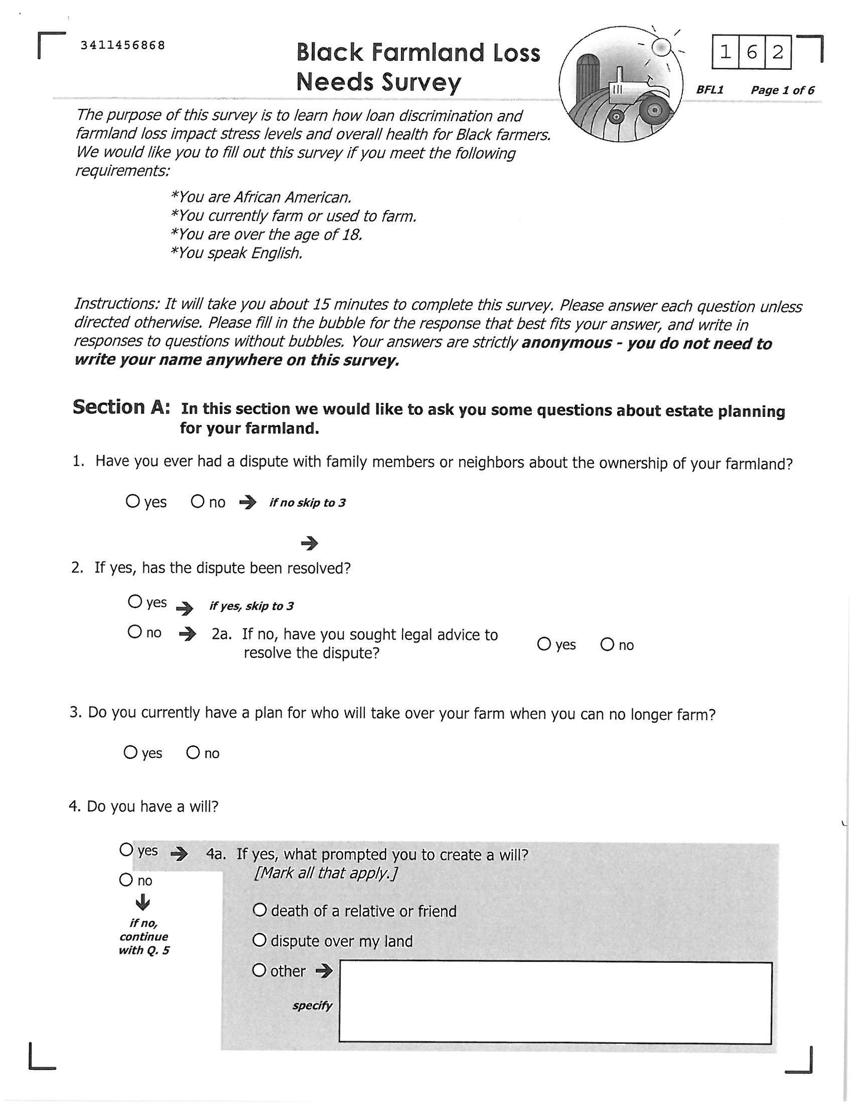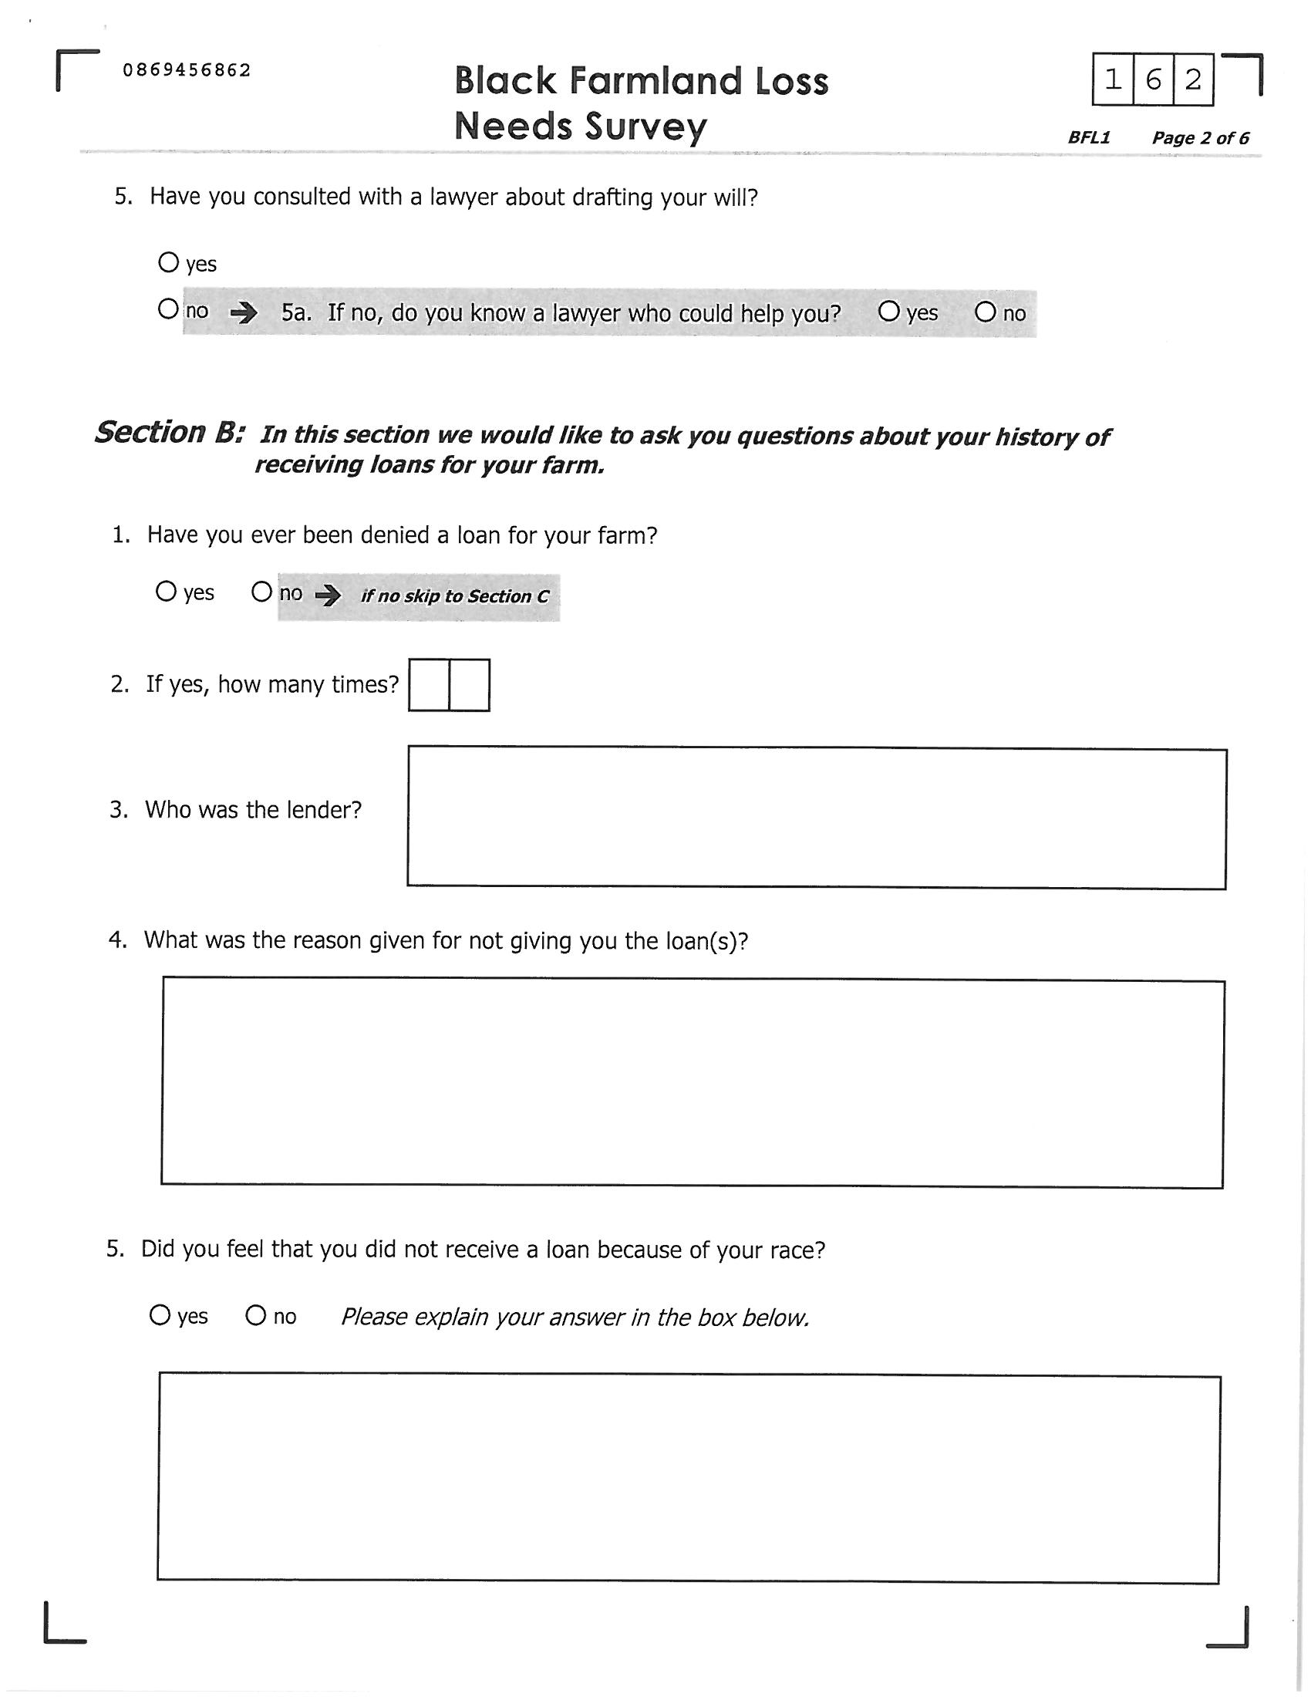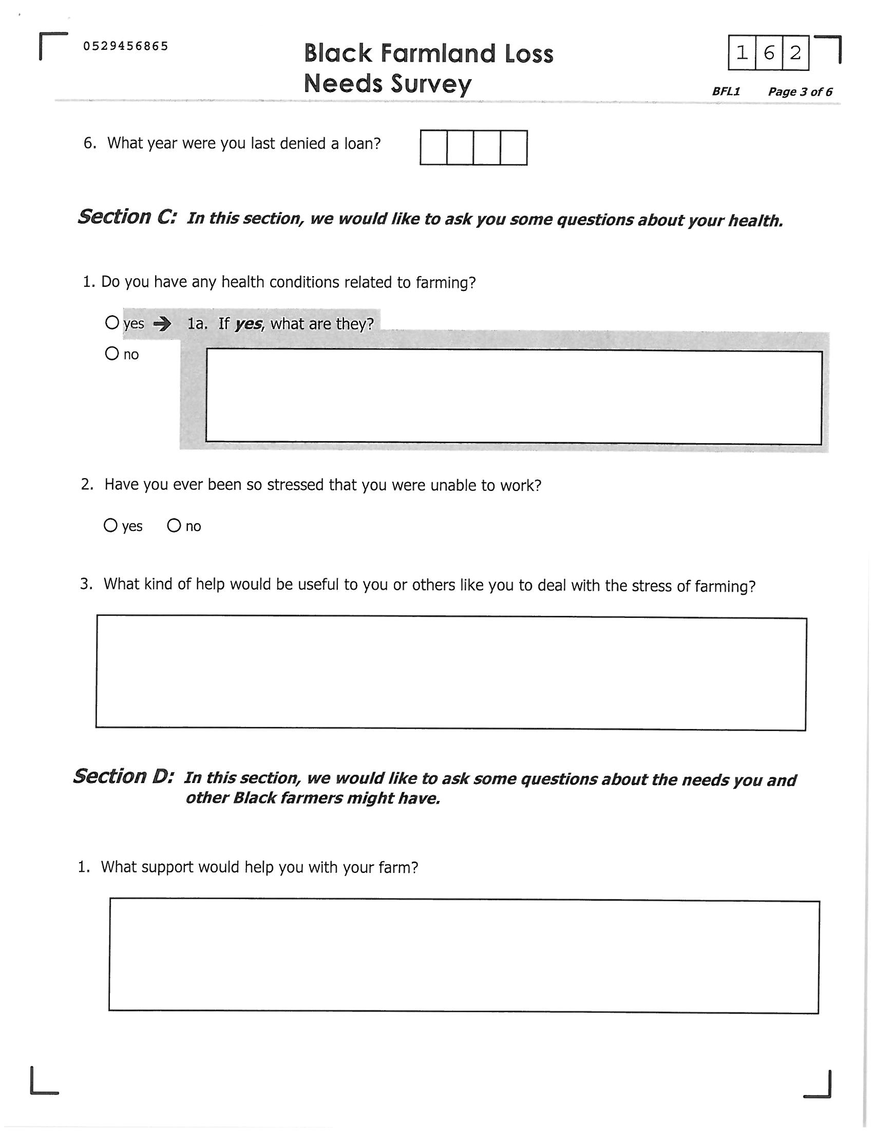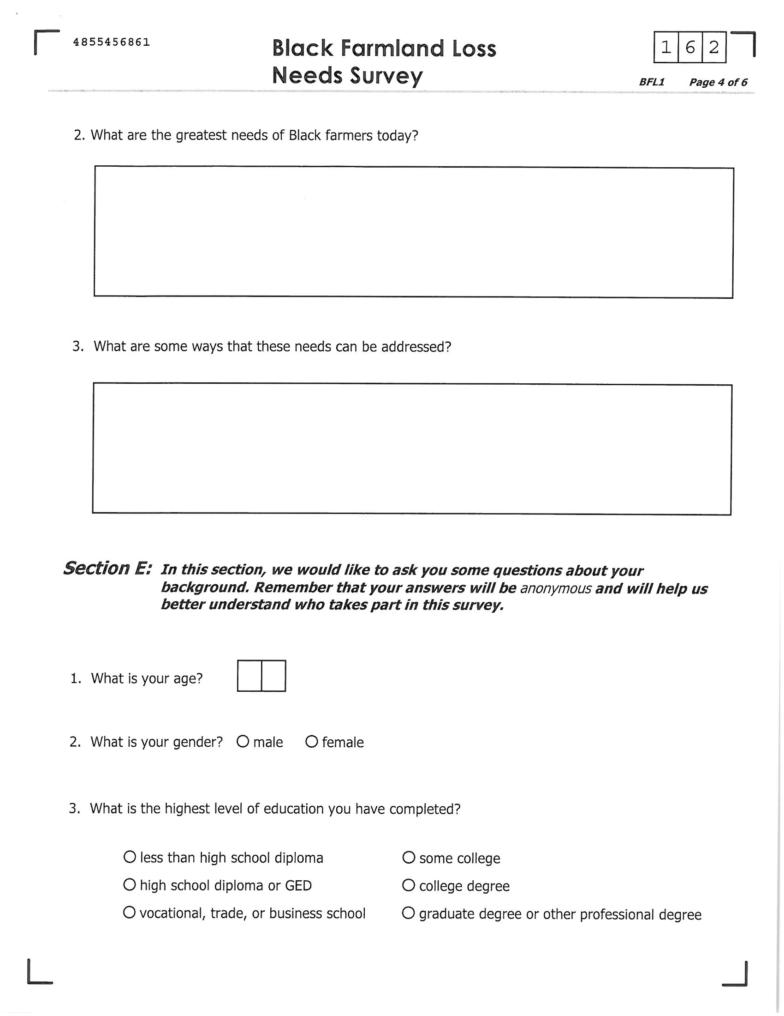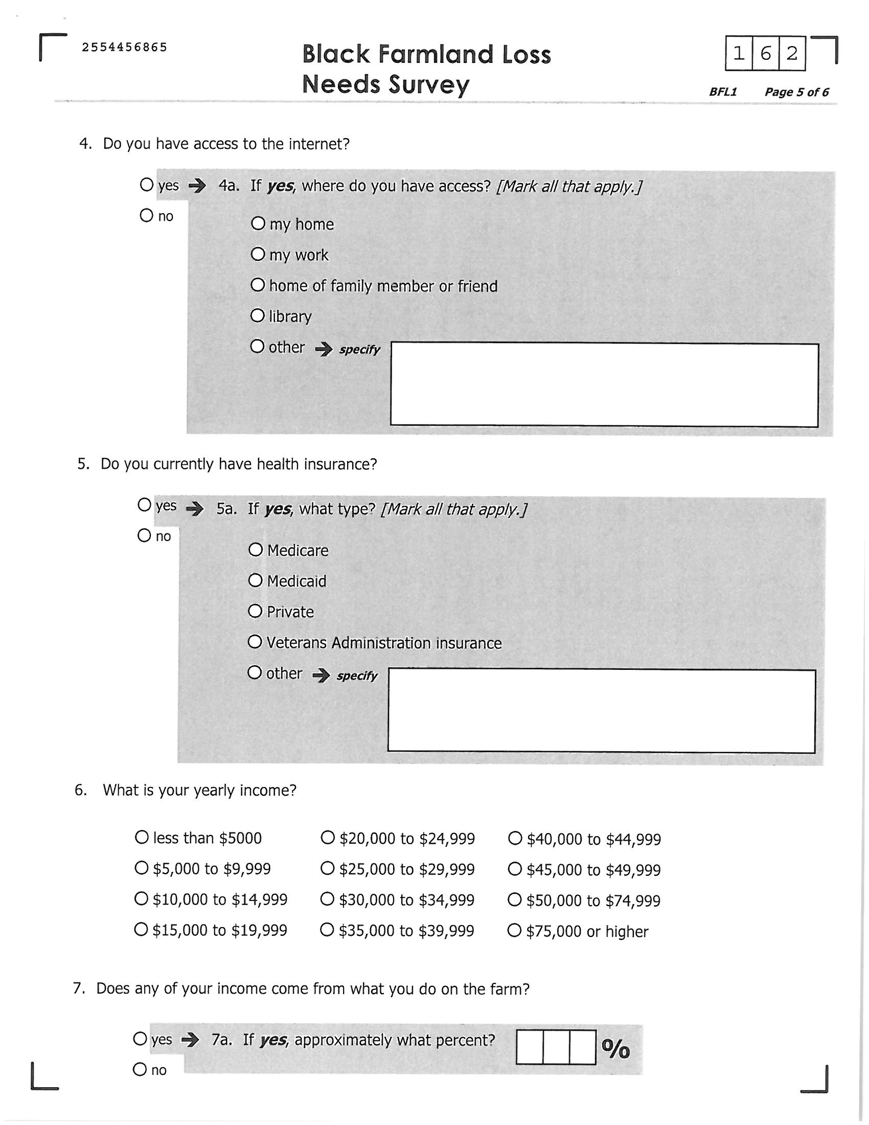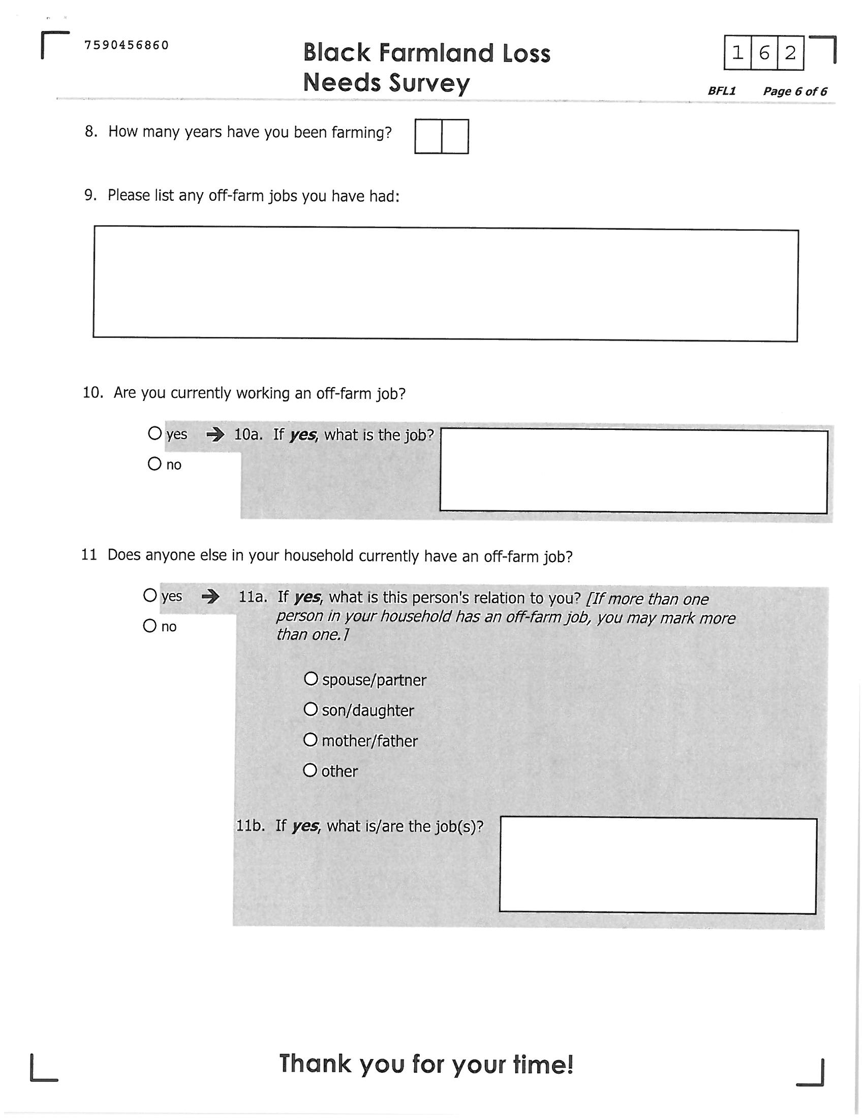
Appendix C
Grant Opportunities for Low Resource and Minority Farmers

Guide to Federal Funding for Local and Regional Food Systems
This is an on-line guide to opportunities for funding in the local and regional food systems realm. There is more detail on some of these opportunities below.
http://sustainableagriculture.net/wp-content/uploads/2010/06/6.18-FINAL-Food-System-Funding-Guide2.pdf

North Carolina Center for Rural Economic Development's Family Farm Innovation Fund
Five state and federal programs are partnering to make $18.4 million in assistance available to North Carolina farmers over the next year. The programs will help farmers:
• Lower energy costs or implement renewable energy projects
• Develop and implement value-added production
• Develop other new sources of farm income
http://www.ncruralcenter.org/images/PDFs/AAC/ageventbookletedit.pdf

Sustainable Agriculture Research and Education (SARE) grants
SARE's four regions offer a number of competitive grants for researchers, agricultural educators, students, farmers and ranchers in the United States http://www.sare.org/Grants/Grants-Information

See page 7 of the North Carolina grant list for a list of Grants to Farmers: http://www.sare.org/Grants/Grant-Summaries-by-State

USDA Specialty Crop Block Grant Program
The purpose of the Specialty Crop Block Grant Program (SCBGP) is to solely enhance the competitiveness of specialty crops. Specialty crops are defined as “fruits, vegetables, tree nuts, dried fruits, horticulture, and nursery crops (including floriculture).” The agency, commission, or department responsible for agriculture within the 50 States, the District of Columbia, the Commonwealth of Puerto Rico, Guam, American Samoa, the U.S. Virgin Islands, and the Commonwealth of the Northern Mariana Islands are eligible to apply for grant funds directly to the USDA.
www.ams.usda.gov/scbgp

Farmers’ Market Promotion Program
The Farmers Market Promotion Program (FMPP) was created through an amendment of the Farmer-to-Consumer Direct Marketing Act of 1976. The grants, administered by the FMPP, are targeted to help improve and expand domestic farmers’ markets, roadside stands, community-supported agriculture programs, agri-tourism activities, and other direct producer-to-consumer market opportunities. Priority status will be granted to those projects that expand healthy food choices in food deserts.
http://www.ams.usda.gov/AMSv1.0/FMPP

Rural Advancement Foundation International’s (RAFI) grant program, the Tobacco Communities Reinvestment Fund
The Reinvestment Fund assists farmers in developing new sources of agricultural income through provision of cost-share grants. NC farmers are eligible to apply for Producer Grant Awards of up to $10,000 for individuals and Community Grant Awards of up to $30,000 for collaborative farmer projects. The grants are competitive; priority is given to projects that provide opportunities for a new generation of farmers and to applicants who had tobacco income at the time of the Master Settlement Agreement.
http://www.rafiusa.org/programs/tobacco/tobacco.html

North Carolina Market Ready Value Added Cost Share Programs
N.C. Value-Added Cost Share The North Carolina Value-Added Cost Share Program (NCVACS) complements the USDA Value-Added Producer Grant (VAPG) by offsetting the costs to N.C. value-added producers for professional services related to the VAPG application process and equipment purchases.

Water Analysis Cost Share Program The N.C. Department of Agriculture & Consumer Services will reimburse growers up to $200 for laboratory analysis to determine the quantitative presence of generic E. coli bacteria in irrigation or wash water by a certified laboratory. Funding for this program is from a USDA specialty crop block grant and is available on a first come, first served basis.
http://plantsforhumanhealth.ncsu.edu/extension/programs-resources/grant-information/cost-share-programs/

USDA Community Food Projects
Community Food Projects fund proactive approaches to making communities more self reliant at maintaining their food systems while addressing food, nutrition, and farm issues. Grants are intended to help eligible private nonprofit entities that need a one-time infusion of federal assistance to establish and carry out multipurpose community food projects. Projects are funded from $10,000-$300,000 and from 1 to 3 years. They are one-time grants that require a dollar-for-dollar match in resources.
http://www.nifa.usda.gov/nea/food/sri/hunger_sri_awards.html

Leadership Grants: Grants for American Small Business and Entrepreneurs
The Leadership Grants Organization is an international funding organization that provides cash awards and in-kind resources to small business owners and entrepreneurs to start or grow a small business. Proceeds are allocated on a discretionary basis contingent upon the applicant demonstrating confidence, initiative, preparedness and a reasonable likelihood of future success. Grant funds allow small business operators to procure needed resources such as goods, services, equipment, inventory, advice, training and professional assistance.
http://www.leadershipgrants.com/smallbusiness/leadership_grants.jsp

North Carolina Commerce Community Development Funds: Small Business & Entrepreneurial Assistance
This grant program, which began in 2007, was designed to assist local governments that are already in the process of developing a coordinated effort to support and grow their community’s existing, small businesses. With $1 million in funding, this grant is expected to help create and retain jobs within our state's most distressed communities. It enables local governments to formulate an economic development strategy to support locally owned and operated businesses. And it assists local governments ready to establish and nurture an entrepreneurial-friendly environment that will benefit small businesses/entrepreneurs now and in the future.
http://www.nccommerce.com/communitydevelopment/investment-assistance/grant-categories/small-business-entrepreneurial-development

USDA National Institute of Food and Agriculture (NIFA) Agriculture and Food Research Initiative (AFRI)
This granting mechanism is more academic in nature, but funds partnerships between agriculture and research sectors.
http://www.csrees.usda.gov/fo/agriculturalandfoodresearchinitiativeafri.cfm

Loan Opportunities for Low Resource and Minority Farmers

Natural Capital Investment Fund (NCIF)
The business investment arm of The Conservation Fund (www.conservationfund.org), a leading national non-profit with a unique dual mission of conservation and economic development. Support for NCIF’s lending activities in North Carolina has been provided by: NC Tobacco Trust Fund, Mary Reynolds Babcock Foundation, Appalachian Regional Commission, the NC Rural Center, the Calvert Foundation, the NC Agricultural Development and Farmland Preservation Trust Fund, the Z. Smith Reynolds Foundation and Wells Fargo. NCIF has recently provided loans to a number of agricultural and value-added enterprises across North Carolina. NCIF has capital available for loans to growers and producers who are diversifying into natural or organic production, or pursuing value-added enterprises involving produce, fruit, grains or protein. Recipients of grants from RAFI-USA, WNC AgOptions or the Resourceful Communities Program’s CNEF grants program are encouraged to apply for a loan if they need additional funding for their diversification efforts or agricultural enterprises. NCIF’s lending is financed in part by the NC Tobacco Trust Fund Commission. NCIF’s Grain Bin Program, which pairs small loans with cost share grants for limited resource farmers has received another grant from the NC Agricultural Development and Farmland Preservation Trust Fund. Farmers are encouraged to apply. To learn if a NCIF loan is a fit for your enterprise, please contact Rick Larson, NC Program Director, at 919-967-2223, ext. 113 or rlarson@conservationfund.org. www.ncifund.org

Recent NCIF loans in North Carolina include:
- Greene County tobacco farmer Neil Moye received an NCIF loan to help fund the start-up of Simply Natural Dairy Farm, an organic dairy that will begin production in 2011.
- 15 limited resource farmers in eastern North Carolina and the Piedmont have been able to install on-farm grain storage bins with small NCIF loans and cost share grants funded by the NC Agriculture Development & Farmland Preservation Trust Fund.
- Annie’s Bakery of Sylva, which produces organic bread and pastries, is using NCIF funds to outfit its new wholesale baking operations in Asheville. The facility will also house the flourmill for the North Carolina Organic Bread Flour Project.

This class-action lawsuit, led by plaintiff Timothy Pigford of North Carolina, ultimately reached the U.S. Supreme Court with then-U.S. Secretary of Agriculture Dan Glickman as the defendant. The court decided in favor of the farmers and the resulting multi-billion dollar settlement from Pigford v. Glickman was the largest civil rights settlement in U.S. history (Hinson & Robinson, 2008). Despite the victory of African-American farmers in Pigford v. Glickman, plaintiffs found the procedures for restitution overly burdensome, including the requirement to obtain records from a similarly situated White farmer to provide evidence of preferential treatment (Hinson & Robinson, 2008). Many also found the time period allotted for claims submissions too short to produce the “evidence of discrimination” required. The 2008 Farm Bill opened an opportunity for farmers filing late to receive federal determination of their claims. Numerous cases representing over 25,000 farmers were consolidated into a new lawsuit, In re Black Farmers Litigation (Pigford II), which awarded African-American farmers an additional $1.15 billion in appropriations through the Senate passed Claims Resolution Act of 2010 (H.R. 4783) approved by the House of Representatives and signed by President Obama on December 8, 2010 (Cowan & Feder, 2010). Still, many Black farmers have not received restitution.

