On Saturday, February 28th, I interviewed Tanner Punnett King, a general manager at Tru Deli & Wine Bar. I structured the interview into five separate parts: 1) Tanner’s upbringing and educational studies, 2) How Tanner became General Manager 3) How Tru Deli & Wine Bar was started, 4) How the business fits in the local food system, and 5) The Future for the restaurant. The overall interview went really well, as Tanner’s infectious personality immediately rid the situation of a contrived interview set up by a student fulfilling a class requirement.
As I mentioned before, I began the interview by delving into Tanner’s upbringing and college experience. Tanner was born on November 26th, 1991, making him one of the younger general managers at twenty three years old. Tanner was born in Mount Airy, North Carolina, as evidenced by his casual swagger. After completing high school, Tanner was accepted into the University of North Carolina at Chapel Hill, where he received a bachelor’s degree in Communications. While at Chapel Hill, Tanner fell in love with Tru Deli due to the sustainable food procurement processes and availability of fresh tasting food.
Tanner and his girlfriend began frequenting Tru Deli & Wine Bar on a regular basis, with Tanner eventually deciding to work there and at Linda’s Bar and Grill. He affectionately calls Linda’s his first love. Tanner utilized his communication knowledge and experience as a server during his school days to become an excellent service worker at Tru. Tanner spoke affectionately about his early days at Tru, fondly commenting that he was mainly in charge of events and catering initially. The founder, Colter Debriee, saw potential in Tanner and just eight months ago promoted him to general manager. As General Manager, Tanner is in charge of scheduling, stocking, pricing, web design, payroll, and marketing, and hiring. When I inquired more about the hiring process at Tru Deli & Wine Bar, Tanner spoke of its unconventional nature. Whereas most bars look mainly at experience when making its hiring decisions, Tanner says that, in addition to experience, he looks at the potential of the applicants to accomplish real change in the world. This is reflected in Tru’s personnel, which is filled with prospective medical and law students, teachers, and business professionals. Tanner proudly spoke of the increase in hiring as the business continues to attract more demand.
This is directly contrasted with Tanner’s memories of the business when it first opened in August, 2012. Colter started the business using the funds from a successful business venture. When I asked Tanner about Colter’s reasons for opening up Tru Deli & Wine Bar, I received a very interesting answer. Colter came back to Chapel Hill after a business meeting and was astounded at the lack of availability of affordable sandwiches and quality wine and beer. He created Tru to fill that void. Furthermore, Tanner spoke of Colter having a unique perspective on the primary goals of Tru Deli. As opposed to most other businesses on Franklin Street, Colter is concerned with more than just the business’ profitability. Although it is important that the business remain profitable, Colter is also very focused on providing an experience that is different from the norms of Franklin Street restaurants and bars, primarily through exceptional customer service and quality food.
With regards to the quality of food, Tanner oversees a lot of the food procurement and was able to speak to me in-depth about where Tru Deli gets its food. Tanner explains that a great accomplishment is Tru’s ability to source all of its bread from Weaver Street Market, a community owned cooperative grocery store focusing on organic and local foods. Likewise, the cheese is goat cheese procured from Holly Grove Farms in Mount Olive, North Carolina, which is only about a two hour drive from Chapel Hill. With regards to the meats, Tanner spoke of how the business originally procured the majority of their meats from a national supplier, but recently made the switch to a regional supplier here in the Southeast region. I could feel how proud Tanner was with this switch, as evidenced by him repeatedly stressing how hard he worked towards making this change. Lastly, the majority of the produce comes from Dannon Farms, which is a wholesale supplier of fresh fruits and vegetables located locally in Raleigh, North Carolina. By sourcing a lot of its inputs from regional and local suppliers, Tru supports the long-term health of the environment, energy conserving practices, local farmers, and a safer food system through decentralization.
Tru Deli & Wine Bar really is one of the most unique restaurants on an otherwise commercialized and environmentally unfriendly Franklin Street. When I asked Tanner about Tru’s future plans, he spoke passionately about the shift towards a completely technology based venture. For example, all of the orders at Tru are processed through an application that Colter himself created. The payment is processed by swiping your credit card directly onto the iPad that you order from. Furthermore, the deli has recently expanded its delivery locations by offering delivery to a variety of unique campus locations, including Davis Library and the Law School Building. Amidst all these rapid change, Tanner says that his favorite meal will always be the same: A Classic BLT with extra avocado and a room-temperature Oskar Blues IPA to top it off.

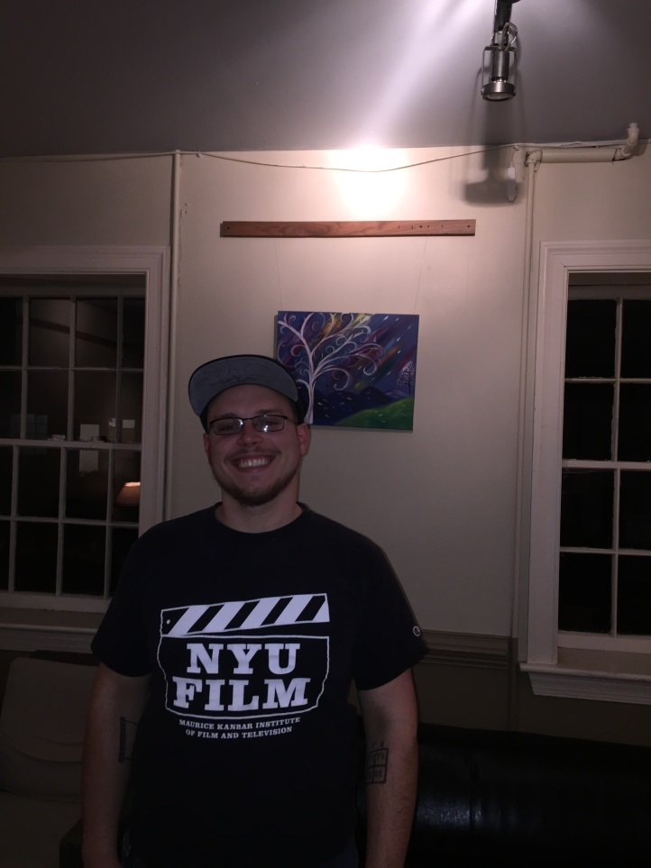

Here is Tanner at Tru Deli & Wine Bar on Saturday, February 28th

