Interview with Ross Flynn of Left Bank Butchery

Talking to Ross Flynn of Left Bank Butchery was not the average interview. I met him at the store before opening when he normally preps for the day. As we spoke he prepared three pigs for sale – carefully sawing ribs, feathering away bits of muscle and fat and skimming the skin.

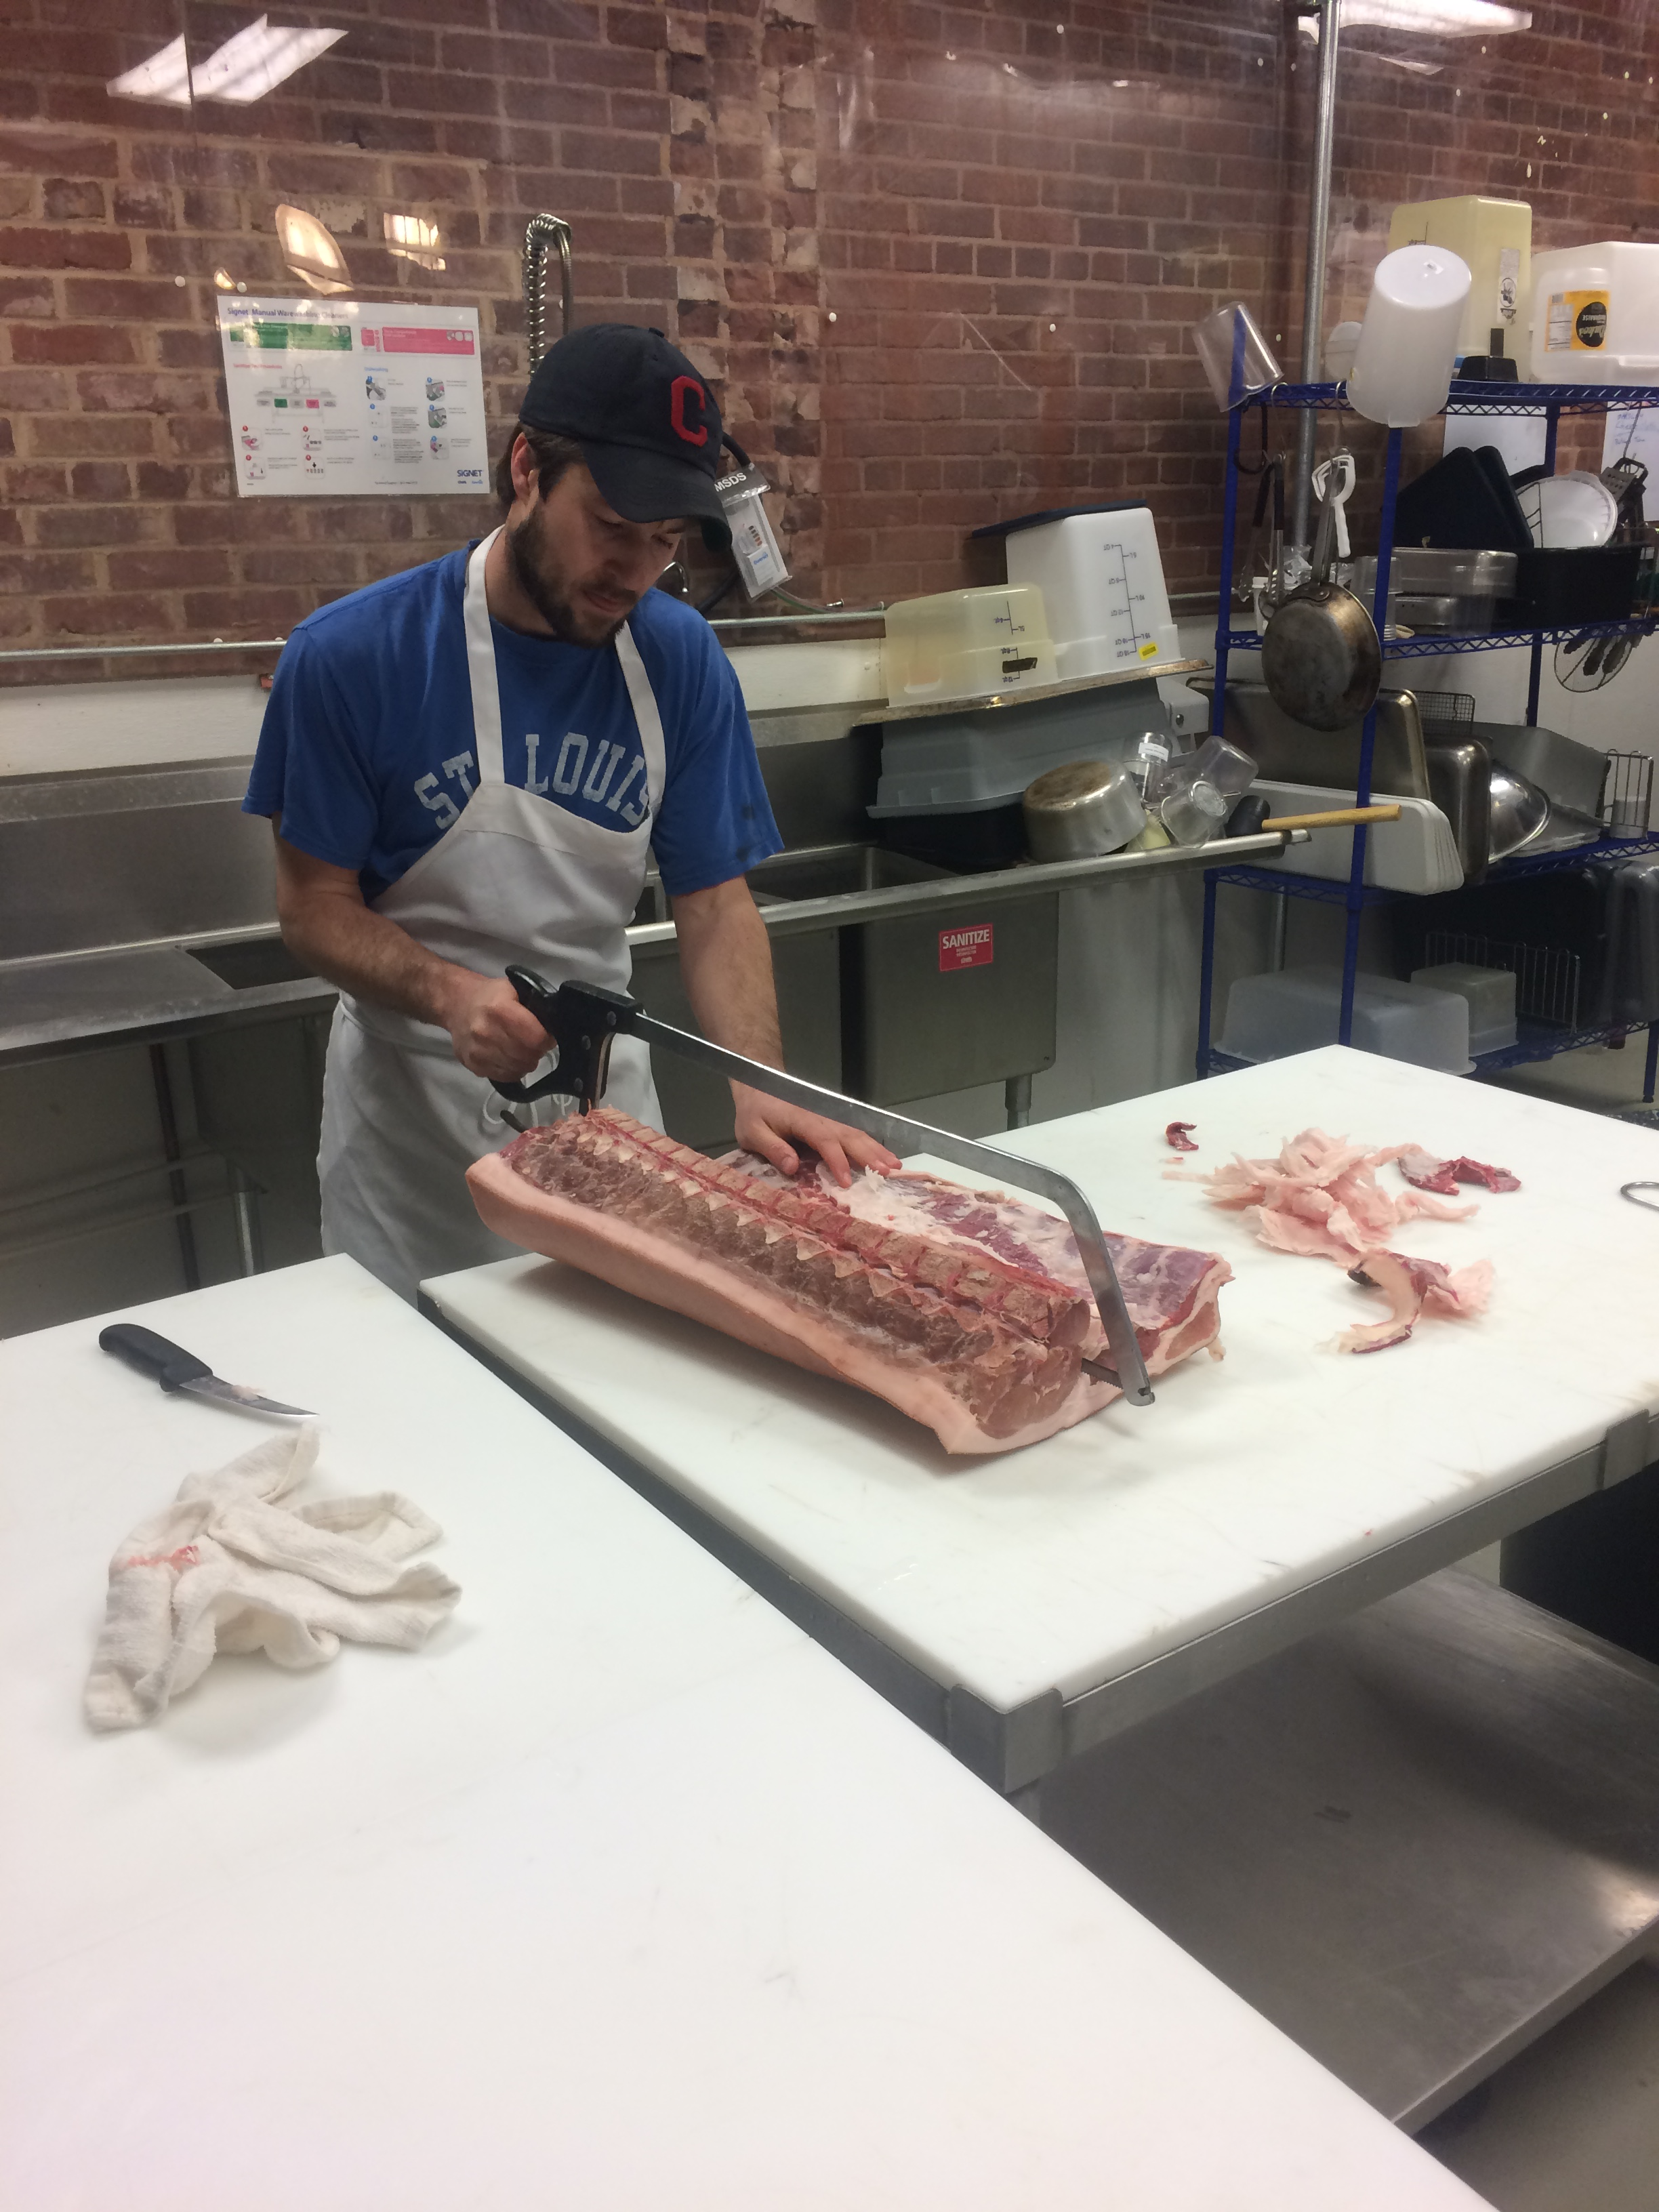
“So how does one become a butcher, in an industry that seems to be dwindling?” I asked. The plan was never to be a butcher, out of college and en route to an MPH he found himself working on a Braeburn, and later Cane Creek, Farm. “I studied human geography and history – which is why I’m a butcher.” He fell in love with farming, but became quickly frustrated seeing the ways that the animals he raised were being processed.

Conventionally, all meat goes to a central abattoir, where animals are killed, processed and packaged. Having all of the components in one place makes it cheaper and more efficient, but unskilled workers lead to poor cuts and a lot of overall waste. In Ross’s words, “they don’t do so well with the cutting, it’s frustrating when you raise a cow for three years and a processor just sort of hacks at it.” After seeing this Ross began to butcher some of the farms’ animals himself, but quickly began spending a lot more time butchering and a lot less time farming, and opened Left Bank in 2014. He still buys from Cane Creek and Braeburn where he got his start and both farms have been integral in founding and running the store. “We want to put the butcher back into that system to change the quality of meat.”

In the foodie world there seems to be two camps – those who are vegetarians and those who aren’t. Ross believes that many of his customers would be vegetarians if they didn’t have such access to good meat they can trust. “My customers care about animals and famers’, I like being able to provide an alternative.” They even have a vegetarian that works in the shop.

Saxapahaw, a town made virtually of a concert venue and a general store, seemed like an odd place to start a butchery. Although it may have been more profitable elsewhere, Ross can’t see himself anywhere else. “I think we might be the only butcher shop in America that can say my animals are up the hill.”

So much of what drove him to start the butchery was the community and the farmers’ who gave him his start. “The farmers’ are so important to why I do this. They are why I do this.” The Saxapahaw community is a tight-knit one with a thriving food community and everything from bakers to jam makers and picklers. When I asked if they ever all had big potlucks, he just laughed and answered, “like every week.”

This community comes not only from the farmers’ he buys from but also from his customers. Having a brick-and-mortar store where customers can talk to the person who cut (and may have raised) their meat gives him, “the ability to talk to someone and even if they have never seen that cut of meat before, say this is what it is and this is why I think you’re going to enjoy it.” These conversations allow him to challenge is customers to try new cuts of meat that may be a lot more sustainable and to try new recipes.

These close relationships also drive Ross to pursue affordability in his product. It’s no secret that sustainable meat is more expensive than conventional, and that it is simply out of a lot of peoples’ budgets. “It weights heavily on me,” he said, “I really believe in what we do and yet I really wish it were more accessible. There is only so much we will ever be able to do.” He does all he can without sacrificing quality to keep the price on his products lower and at least provides a range of options to his customers. He practices seam butchering, a technique that isolates muscle groups, to get more meat out of the animal, even though it may not give as many pork chops as a traditional manufacturer. Frequently customers will give them their budget and he’ll figure out the best cuts to feed them accordingly.

After our conversation I decided to put this to the test and gave him a $20 budget to feed 4 people for at least 2 meals. I left the interview with a passenger seat full of pork strip-steaks (an unusual cut) for fajitas, sausages for soup and a bag brimming with pigskins for my dog.

Oh, and Ross’s favourite meal – grilled fish. Go figure.

